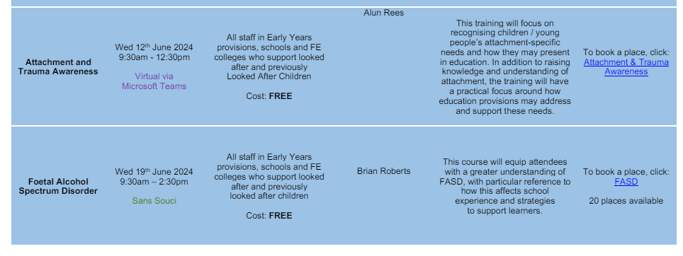

Attachment booking - https://forms.office.com/pages/responsepage.aspx?id=rgObbdmfb06EmZuschoIFH2vFhm4_cJNohpNmECOcXdUOEdVRVlEVFg3SFJPQkxYQU82SDlYMDY0SiQlQCN0PWcu

FASD

